Little Italy 5K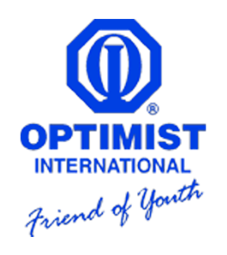

Saturday August 31, 2024

**All proceeds to benefit**

**The Youth Activities of the Clinton Breakfast Optimist Club and the South Vermillion Middle School Dance Team**

TITLE SPONSOR $1000

Gold Level Sponsor $250 - $500

Silver Level Sponsor $100 - $249

Bronze Level Sponsor $50 - $99

Sponsors will have their names/logo added to the official 2024 race t-shirt

All sponsors will be recognized before the start of the race and during the awards presentation.

Additional Information:

Macy Smith

812-241-9236

Email: [Mmumaw20@gmail.com](mailto:Mmumaw20@gmail.com)

Mail Sponsors to:

Clinton Breakfast Optimist

PO BOX 92

Clinton, IN 47842

Make Checks Payable to: Clinton Breakfast Optimist Club – 5k Run

MUST BE returned by **Wednesday August 7th**to ensure name on shirt

Sponsor name to be added to shirt: __________________________________________________

Sponsor Phone Number and/or Email: ________________________________________________

Sponsor Level: ___________________________________________________________________

Signature: ______________________________________ Date: ____________